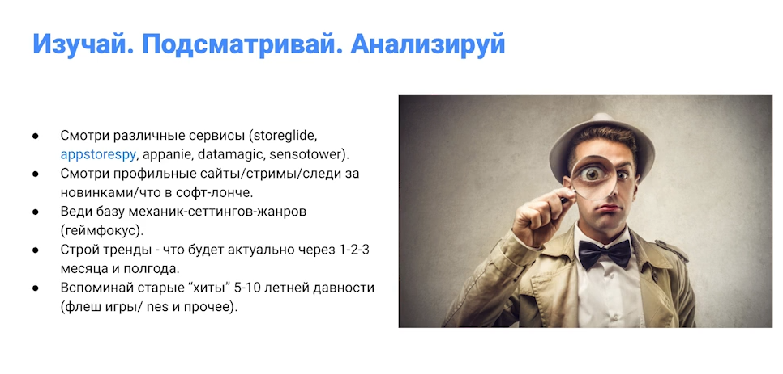
Touch Arcade, Pocket Gamer – софт лонч

App Magic -> ТРЕНДЫ
https://appmagic.rocks/

